Project 6 Coin Detection
Name: Pawan Period: 2 Date: 1/23/2020
Did you create the edge matrix? yes
Did you create the gradient direction matrix? yes
Did you identify circles? no
Below do the following:
- Paste here 3 clear picture of the initial picture, the picture with the edges, the picture with the original image and the circles you detected drawn in red.
- Paste the content of your results.txt file
- Write a succinct journal (max. 2 pages) of what did you attempt during the 2 weeks you worked on this project, what worked, what did not work, what did you debug. Explain your successes and failure in approaching this lab and how did you try to overcome them.

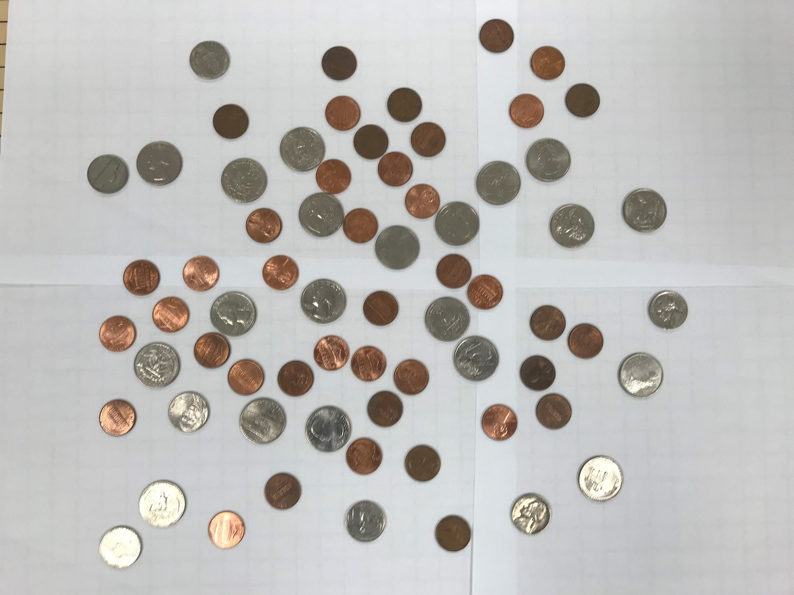
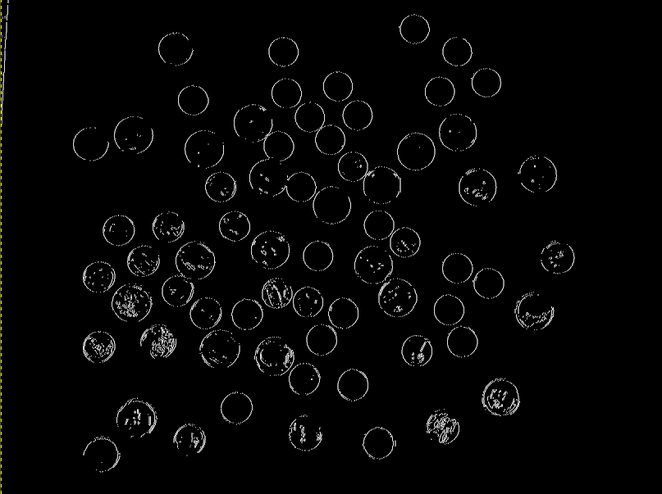
Journal:
On the first day, I spent class downloading the various coin files and converting them to PPM and performing canny edge detection. The initial image was very high resolution, so I had to downscale them to 1/3 the original size. I also created 2 test images: one with a single coin, and one with 3 different coins.
One challenge that I faced was just creating a good edge image. I spent a long time just trying to tune the thresholds so that the outlines of the coins were crisp. The problem was that the texture of the coin created many meaningless edges. I had to compromise between these two features.
I spent significant time thinking about the data-structure I would use to store the votes and the distance to the pixel that got voted. At first I decided to use a map where the keys are (x,y) pairs and the values are a vector of votes. This led to the problem of trying to hash a Point object. I wasn’t able to figure out how to do it, and a friend suggested just using a 3-d matrix. I was confused how that worked because radii are continuous, but it turns out that the coins have radii that fall into a fixed range so there is a upper and lower bound that you are looking for. Also, pixels are inherently discrete, so restricting radii to integers is fine.
I had to spent a significant time on the voting aspect as well. The first way I tried doing it was to use the gradient and draw a continuous line along that direction. To do that I took my lab 1 code and modified it to voting in a matrix rather than drawing. The problem was that it was extremely slow. It took around 10 seconds just for each pixel. Something was clearly wrong. I spent a lot of time debugging why it was so slow. One thing I thought was that I was re-calculating the distance from the start to the pixel being voted, but since the distance from one pixel on the line to the next is constant, I can incrementally increase the distance. This change did help, but it wasn’t the bottleneck issue. I was really confused because my lab 1 wasn’t this slow.
I then decided to abandon this approach and think of a better way. Instead of voting on the whole line, I realized that all the pixels on that line have coordinates of (radius * cos(gradient angle) , radius * sin(gradient angle)). This method was also easier to implement. To visualize the votes, I summed the votes for each pixel up and binned them. 0-5 red, 6-10 green 11+ blue. The first time I ran it, the image was black. It ran into a segmentation fault. I then realized that it was because r*cos(theta) could be negative and this could mean that it tried voting for a pixel that was out of bounds. I changed it so that it checked whether the pixel was within bounds.

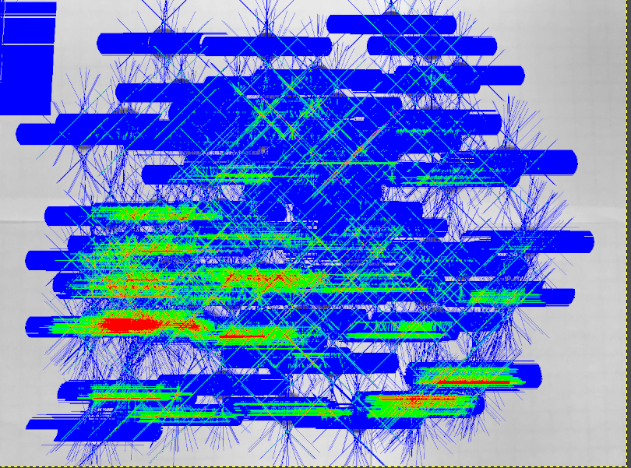
This is the result. What I can notice is that coins were surrounded by a thick horizontal line of votes. This caused the high voted areas (red) to also be rather wide. Also, many of the coins don’t even have an area of high concentration of votes. In other words, regardless of my threshold, it won’t properly detect circles.
At this point, I ran out of time to investigate how to improve the circle detection.

